**P510/3**

**PHYSICS**

PRACTICAL

**Paper 3**

**3 ¼ hours**

*ENTEBBE*

**ENTEBBE JOINT EXAMINATION BUREAU**

**Uganda Advanced Certificate of Education**

PHYSICS PRACTICAL

Paper 3

**3 hours 15 minutes**

**INSTRUCTIONS TO CANDIDATES:**

*Attempt* **question one** *and* **one** *other question.*

*Candidates are* **not** *allowed to use the apparatus or write for the first fifteen minutes.*

*Graph papers are provided.*

*Mathematical tables and non – programmable scientific calculators may be used.*

*Write on one side of the paper only.*

*Candidates are expected to record on their scripts all their observations as these observations are made and to plan the presentation of the records so that it is not necessary to make a fair copy of them. The working of the answers is to be handed in.*

*Details on the questions paper should not be repeated in the answer, nor is the theory of the experiment unless specifically asked for. Candidates should, however, record any special precautions they have taken and any particular feature of their method of going about the experiment.*

*Marks are given mainly for a clear record of the observations actually made, for their suitability and accuracy, and for the use made of them.*

**A – PH – III *2023 Entebbe Joint Examination Bureau: Physics* Turn Over**

1. In this experiment, you will determine the
2. moment of inertia, ***I*** of a metre rule labeled *X* about its centre.
3. Radius of gyration, *K* of a compound pendulum and acceleration due to gravity, *g*. *(34 marks)*

**PART 1**

1. Balance the wooden metre rule labeled *X* provided on a knife edge.
2. Record the position of the balancing point, *G*.
3. Measure and record the mass, *M* of the metre rule, *X* in *kg*.

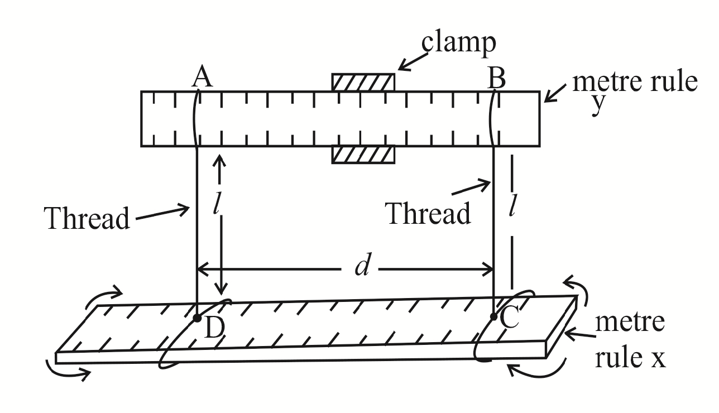

**Fig I**

1. Clamp the metre rule labeled Y as shown in figure I.
2. Tie threads ***AD*** and ***BC*** at the *35.0 cm* and *65.0 cm* marks of the metre rule, *X* such that they are a separation, d. record the distance, *d*.
3. Adjust the length, *l* of each piece of thread to *50.0 cm*.
4. Displace the metre rule *X* about the vertical through its centre through a small angle and release it to oscillate in the horizontal plane as shown in the figure I.
5. Measure and record the time for 20 oscillations.
6. Calculate the period, *T*
7. Calculate the moment of inertia, ***I*** from the expression:

***I*** = *Mg(Td)2* where g = 10 *ms-1* and π = 3.14

16π2 *l*

**2**

**Method II**

1. Clamp the cork with an optical pin passing through it so that the pin is horizontal.

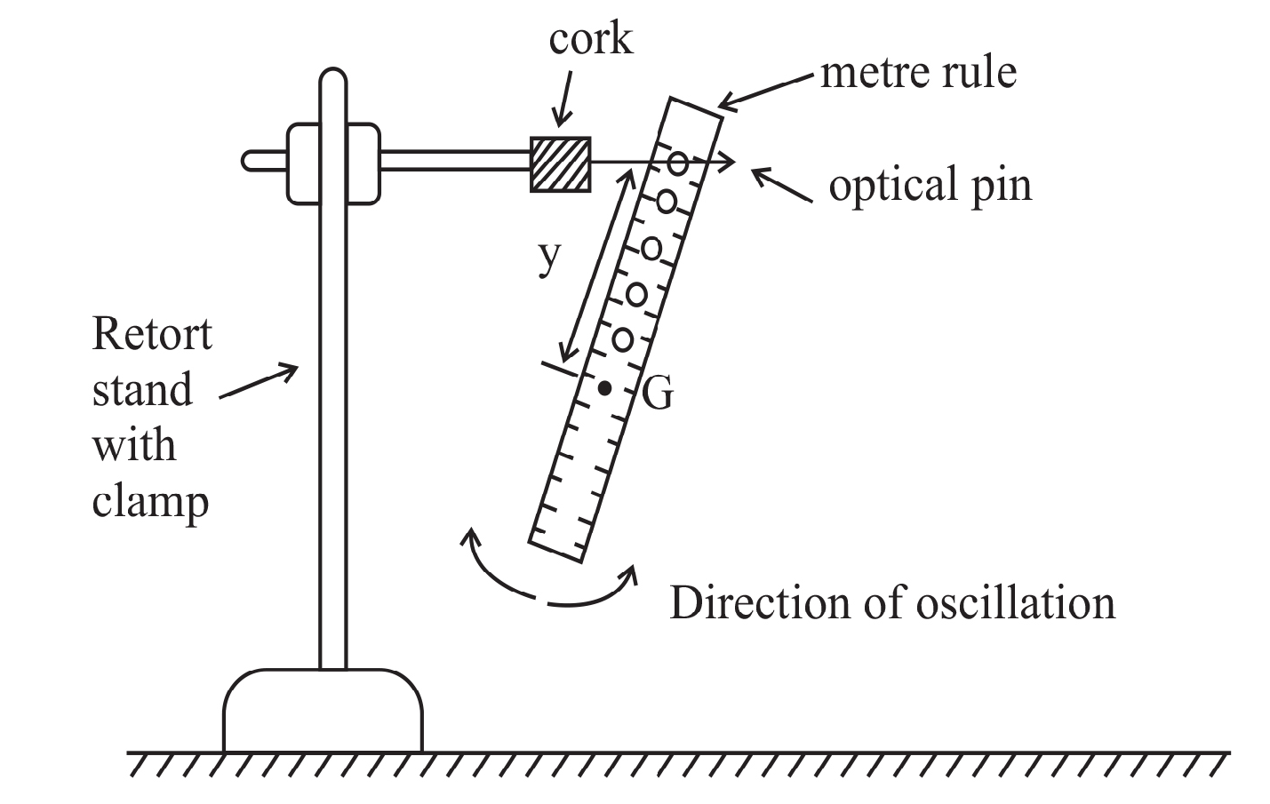

**Fig II**

1. Suspend the metre rule, *X* by passing a pin through the first hole from one end of the metre rule as shown in figure 2.

1. Determine the distance, *y* in metres from *G* to the point of suspension.
2. Displace the lower end of the metre rule through a small angle and release it.
3. Measure and record the time for 20 oscillations in the vertical plane.
4. Determine the period ***T***.
5. Repeat procedures from *(b)* to *(f)* for the other holes.
6. Record your results in a suitable table including values of *T2y* and *y2*.
7. Plot a graph of *T2y* against *y2.*

1. Determine the slope, ***S*** of your graph.
2. Calculate the acceleration due to gravity, *g* from the expression:

*4π2*

*S*

*g*=

1. Read and record the intercept, *C* on the *T2y* axis.
2. Determine the radius of gyration, *K* from the expression:

*Cg*

*4π2*

*K*= where π = 3.14

**3**

**Turn Over**

1. In this experiment you will determine the constant, ***K*** of the material of the glass block provided by using two methods. *(33 marks)*

**METHOD I**

1. Fix a plain sheet of paper on a soft board using drawing pins.
2. Place the glass block with its largest face on the paper and trace its outline *WXYZ*.

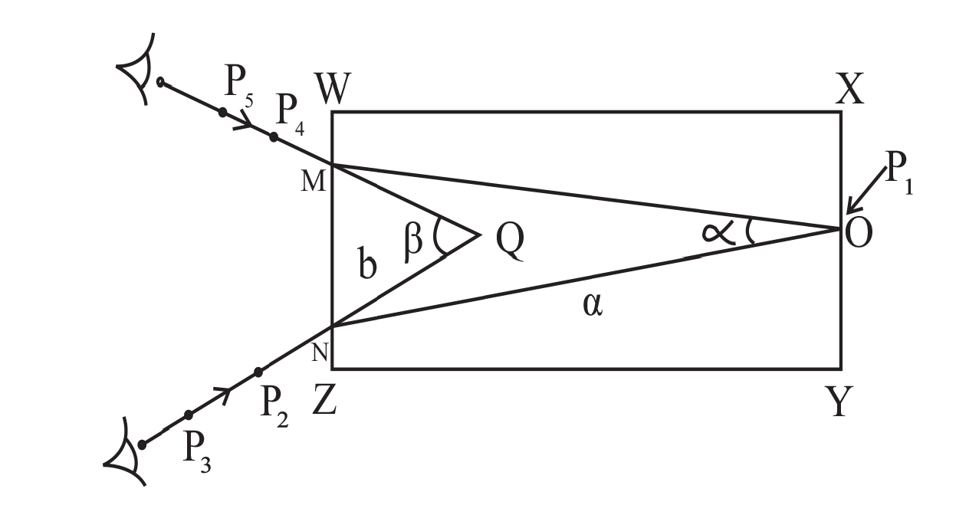

**Fig III**

1. Remove the glass block from its outline and mask the midpoint, *O* of side *XY*.
2. Replace the glass block on its outline and fix an optical pin, *P* vertically and close to the side *XY* at *O*.
3. While looking through the glass block from side *WZ*, fix pins *P2* and *P3* such that they appear to be in line with the image of *P1*. Mark the positions of *P2*and P3*.*
4. Remove pins *P2* and *P3*.
5. While looking from side *WZ* again, move your eyes towards the left hand side of the line through *O* until another sharp image of *O* is seen again.
6. Fix pins *P4* and *P5* such that they are also in line with the image of *P1* as shown in figure 3 above. Mark the positions of *P4* and *P5.*
7. Remove pins *P4* and *P5*.

**4**

1. Remove the glass block and draw lines through P3, P2 and through P5, P4 to their point of intersection, Q.
2. Join *O* to *M* and also *O* to *N*.
3. Measure and record angles α and β.
4. Measure and record distances *ON* = *a* and *QN* = *b*.
5. Calculate the constant, ***K***  of the glass block from the expression:

*α*

*2*

*K1* = *a* Cos

*β*

*2*

*b* Cos

**METHOD II**

1. Measure and record width, ***t*** of the glass block.
2. Fix the plain white sheet of paper on the soft board using drawing pins.
3. Place the glass block in the middle of the plain sheet of paper with the largest face upwards and trace its outline *WXYZ*.
4. Remove the glass block.
5. Construct a perpendicular NA at *A*, where *WA* = ¼ WX.
6. Draw a line *OA* such that the angle *i* = 800 as shown in figure 4.

*O P1 N*

*A l*

**Fig IV**

*P2*

***i***

*W X*

*P3*

*B*

*Z Y*

*P4*

1. Fix two optical pins *P1* and *P2*on the line, *OA*.
2. While looking through the glass block from side *YZ*, fix pins *P3* and *P4* such that they appear in line with the image of *P1* and *P2*.
3. Remove the glass block and the pins.
4. Draw a line through *P3* and *P4* to meet *YZ* at *B*.
5. Join *B* to *A*.

**Turn Over**

1. Measure and record length, *l* of *AB*.
2. Repeat the procedures from *(f)* to *(l)* for values of *i* = 700, 600, 500, 400 and 300.

*1*

*l2*

1. Tabulate your results including values of and cos2*i*.

*1*

*l2*

1. Plot a graph of against cos2*i*.
2. Find the slope, ***S*** of the graph.

*1*

*l2*

1. Determine the intercept, *C* on the axis.
2. Calculate *K2* from the expression:

*K2 =*

*-C*

*S*

1. Find the value of *K* from the expression:

*K* = ½ *(K1 + K2)*

**HAND IN YOUR TRACING PAPER TOGETHER WITH YOUR SCRIPT**

1. In this experiment you will determine the
2. resistance per metre, S of the bare wire labeled *W*.
3. internal resistance, r of the dry cell labeled *E1*.

**PART I**

1. Connect the circuit shown in figure 5 with length, x = 1.00 m.

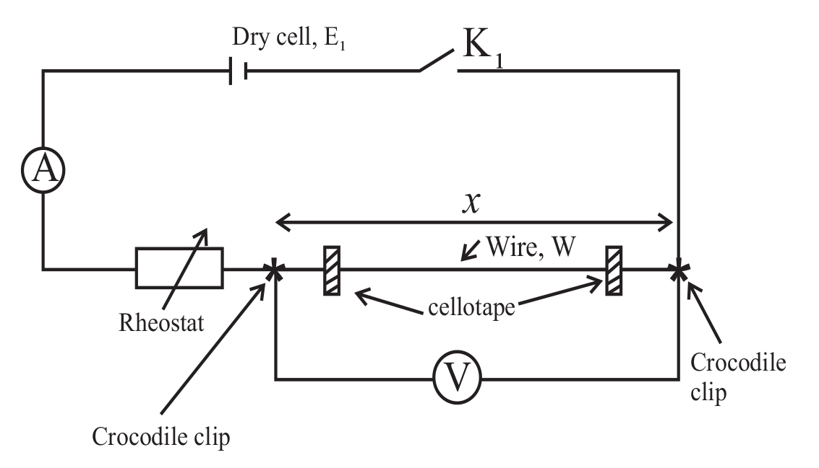

**Fig V**

1. Close switch *K1* and adjust the rheostat so that the ammeter indicates a current *I1* = 0.06A.

**6**

1. Read and adjust the voltmeter reading, *V1*
2. Calculate *S1* from the expression:

*V1*

*I1x*

*S1 =*

1. Repeat procedure *(b)* for *I2* = *0.08A*, read and record the voltmeter reading *V2*.
2. Calculate S2 from the expression:

*V2*

*I2x*

*S2* =

1. Calculate *S* from the expression:

*S1 + S2*

*2*

*S* =

**PART II**

1. Connect the circuit shown in figure 6.

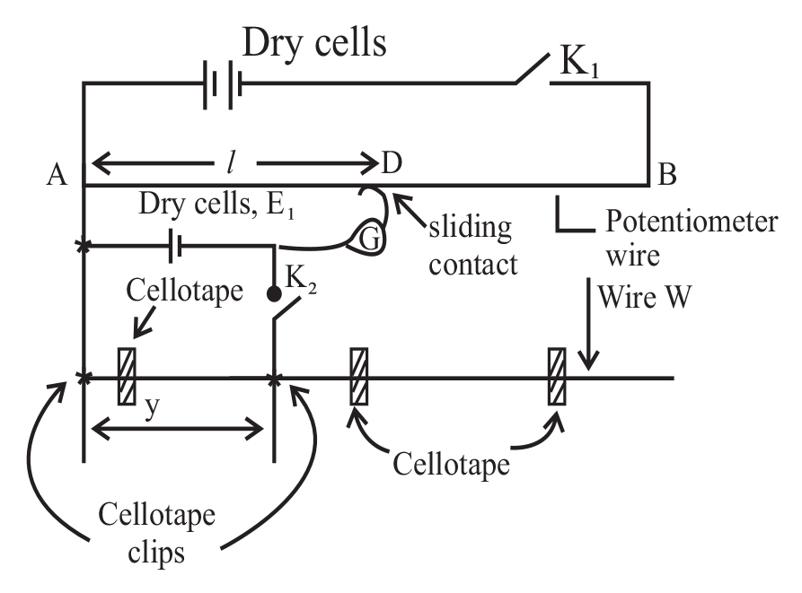

**Fig VI**

1. With switch *K2* open and switch *K1* closed, use the sliding contact to find the balance length, *l0* in metres.
2. Open switch *K1*
3. Adjust the length y to *0.300 m*.
4. Close switches *K1* and *K2*.

**7**

**Turn over**

1. Move the sliding contact, *D* along the potentiometer slide wire *AB* until a point is found where the centre zero galvanometer, *G* shows no deflection.
2. Read and record the balance length, *l* in metres.
3. Open switches *K1* and *K2*.
4. Repeat procedures *(d)* to *(h)* for *y* = *0.400, 0.500, 0.600, 0.700* and *0.800 m*.

*1*

*l*

1. Record your results in a suitable table including values of

*1*

*y*

against

*1*

*y*

*1*

*l*

1. Plot a graph of against
2. Find the slope, *β* of the graph.
3. Calculate the internal resistance, *r* of the dry cell, *E1* from the expression:

*r*

*Sl0*

*β* =

**END**